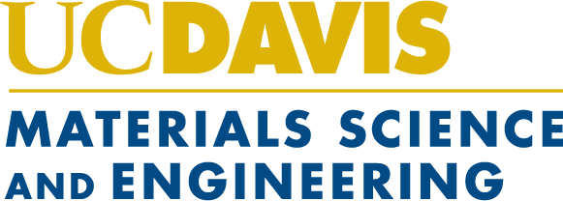

Advanced Materials Characterization and Testing Laboratory
Recharge Rates
Please note that rates are subject to change. Rates are effective July 1, 2023

Rate Category | JEOL 2100F-AC TEM | Thermo Fisher Quattro S ESEM | Kratos AXIS Supra XPS | Rigaku SmartLab Powder XRD | Rigaku SmartLab Thin Film XRD | Ion Mill | Sample Prep Lab
UC Davis Internal User
Unassisted | $60.24 | $60.24 | $70.77 | TBD | TBD | $29.98 | $68.63
Assisted/Training | $134.53 | $134.53 | $145.06 | TBD | TBD | $103.27 | $142.92
Other Non-UC Universities, National or Government Labs, or Non-for-profit Organizations
Unassisted | $86.05 | $81.92 | $96.24 | TBD | TBD | $39.42 | $93.34
Assisted/Training | $187.09 | $182.96 | $197.28 | TBD | TBD | $140.46 | $194.38
Industry User
Unassisted | $256.05 | $121.92 | $131.24 | TBD | TBD | $39.42 | $93.34
Assisted/Training | $357.09 | $222.96 | $232.28 | TBD | TBD | $140.46 | $194.38

